**www.Gympik.com**

Apart from homepage and other static pages there would be 2 main workflows:

1) User registration:

From home page user can click on register hyperlink which will take user to a brief focussed pop-up to collect fields-

First Name, Last Name, Mobile, Email id, password, confirm password.

Once user registers, an email should be sent to given id for account activation.

On account activation user should get a welcome email

On the very first time after account activation when user logs in user would need to fill-in few mandatory details (other details (First Name, Last Name, Mobile, Email id, password, confirm password.) should also be present on this form but prefilled and non-editable)-

Pic- User should have an option to upload or click a webcam pic. (not mandatory)

Description (about urself, not mandatory)- multiple line text box for user to type in couple of lines (not mandatory

Address (mandatory)- multiple fields to distinguish locality and pincode- total 7 text boxes i.e. 1st- for home name/no., 2nd for road name, 3rd for City (dropdown), 4th for locality (kind of a dropdown as user would get values from DB, 5th for pincode, 6th state and 7th country (dropdown)

Home Phone (including country code- dropdown)

DoB (mandatory)- DD-MM-YYYY calendar to choose from

Gender(mandatory)- dropdown,

Current Weight(mandatory)- text box and a dropdown for scale,

Goal Weight(mandatory)- text box and a dropdown for scale,

Height(mandatory)- Text box and a dropdown for scale,

Medical history/allergies(mandatory)- All q’s will have radio button yes or no.

1) Have you ever been diagnosed with a heart condition or advised to avoid physical activity by a doctor?

2) Have you ever had a heart attack or stroke?

3) Do you feel pain in your chest when you do physical activity?

4) During the past month, have you had chest pain when you have NOT been doing physical activity?

5) Do you currently take any prescribed drugs for blood pressure or a heart condition?

6) Do you have a pacemaker or defibrillator?

7) Have you ever passed out while working out?

8) Do you lose your balance due to dizziness or even lose consciousness?

9) Have you had a recent hip or knee replacement?

10) Do you have any physical injuries, recent surgeries or physical conditions of any kind that would prevent you from doing certain exercises?

11) Are you currently pregnant, think you might be pregnant or have you given birth less than 6 weeks ago? (This should be displayed only when user selects gender as female)

We can use the above pop-up for the edit profile functionaltiy. Only below fields would be editable:

Password, mobile no., home no., Address, pic, description,current weight and goal weight.

After account activation via email link, when user logs in first time he/she would need to provide few mandatory data. Typical form fields to collect user data.

We can have a similar implementation where after authenticating the login credentials user would land on the dashboard page. In case if user logs in first time then the dashboard page will be shaded and there will be a focussed pop-up to present form for data collection. User would not be able to close the pop-up. There will be two buttons- submit and cancel. Cancel button will take user to home page. Submit button will verify the mandatory data and store them in user profile and let user be on dashboard.

The dashboard would be the home page after user logs-in. Dashboard title- “GymPik Fitness ”

Dashboard would have multiple tabs/links to left side (with a small respective pic for each tab pan) and respective info on right( like tab-pans) for user to view/add data like current measurements, target goal, daily intakes, etc.

Tabs details:-

1) Daily workout schedule- This will be a typical work schedule where user will have a provision to select from dropdown if a particular exercise is completed or not. The workout schedule would fetch from db which either be created by trainer or by admin or by user itself.

For each exercise there will be details display for example Cardio- running, speed, incline, distance, level etc.

Below the exercise schedule user would have an option to enter footnotes and see any notes enter by trainer

On the right side top corner of the tab pan there will be a module showing the graphical progress of user daily calorie burn i.e. Once user acknowledge a particular workout completed the no. of calories would be added in the days graph.

Below the graph user would have a provision for creating/adding workouts for a day or week schedule. For addition user should get a focussed pop-up implementation to select predefined workouts.There is no option for user to add any custom workouts.

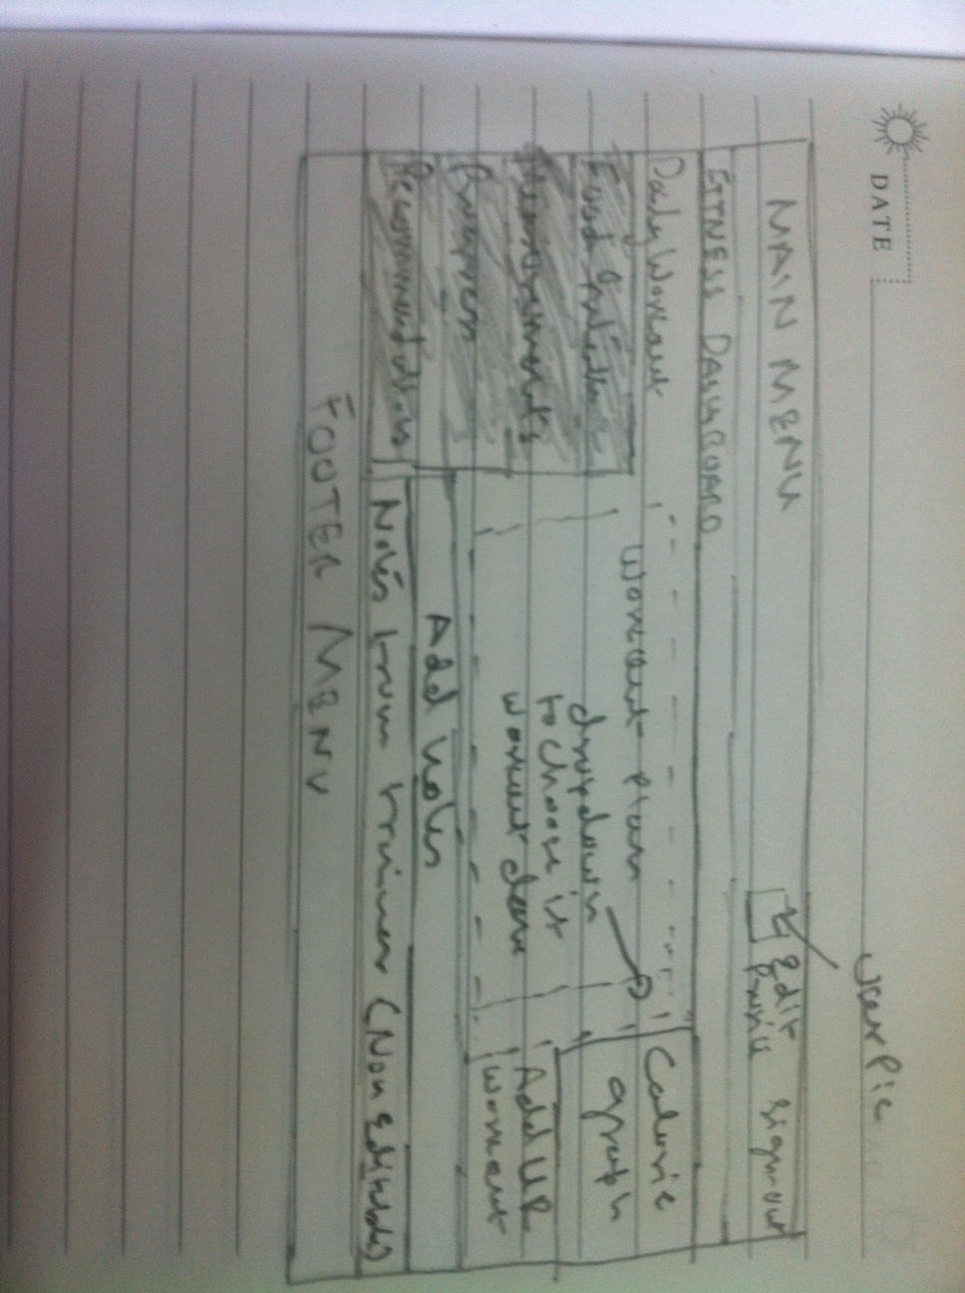

2) Calories Intake- On this tab user can enter daily meals/anything consumed and track the calories intake.

To start on this tab there will be a text box asking “What did you eat today” (this is not a lable but in the text box. Soon user clicks on the box this disappears. There will be “Add Food” button to add the food entry in a daily log. While user types he/she should get relevant suggestion list (like google search)

Below the box user would have a provision to select a serving size and meal type (dropdown for breakfast, lunch, dinner or snacks)

On the right of the text box (above two) there will be a rectangular box with 3 subtabs- Food Journal, Recent and Custom. Idea is to provide an option to user to select entry from categorised list. From the recent tab user can quickly select any entry which he/she might have choose in last one week and Custom tab will list all the custom meals added by user.

The above layout would take 2/3rd of the tab. The rest 1/3rd on the right side would display the calories intake graph and an option for user to add custom meal, which would be a focussed pop-up to take entries.

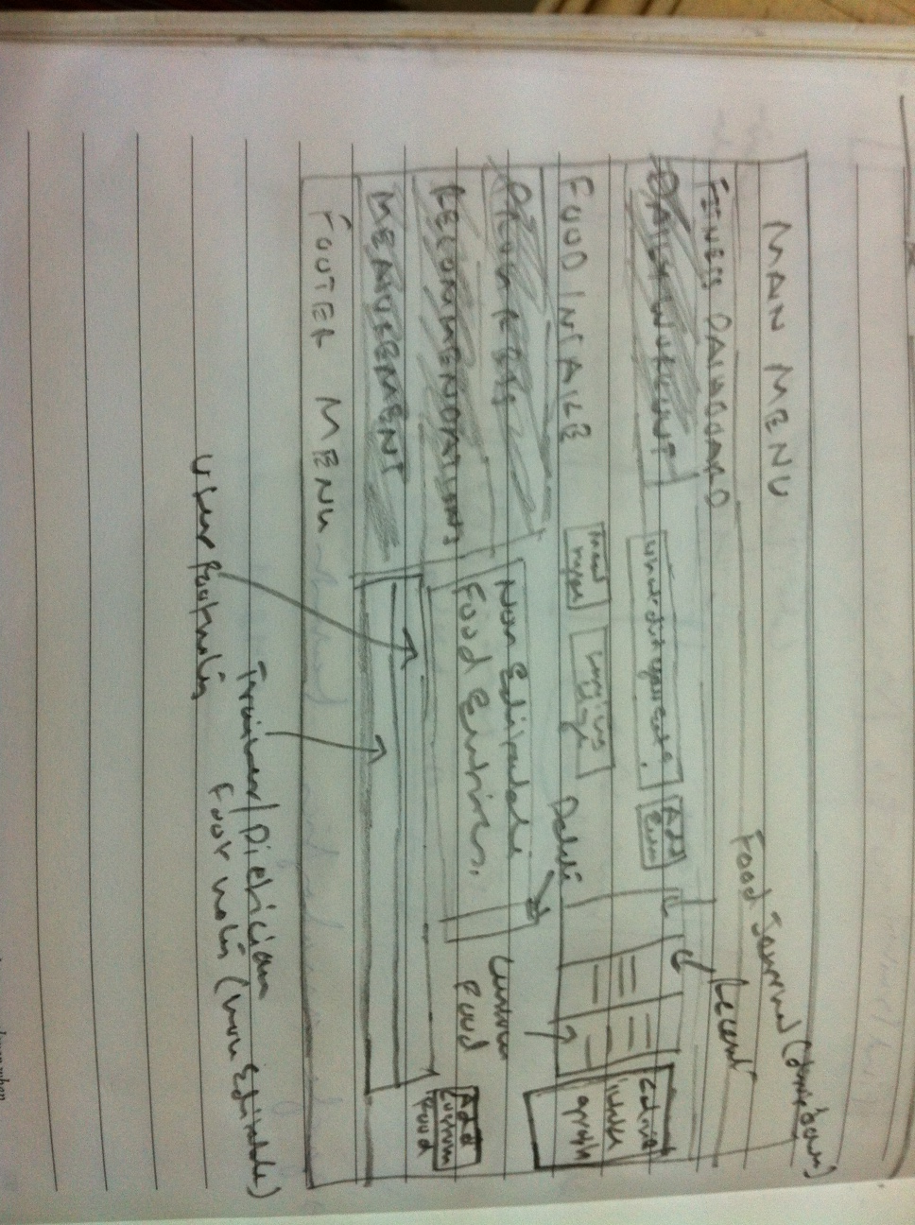

Add a submit button which would confirm the final action from user to enter data into db. In case if user enters food data or notes and forget to submit while changing tabs or moving away from this tab then a pop-up message should ask for a confirmation if the details need to be added or not.

On the footer of the tab, user would have an option to enter footnotes and see any notes enter by trainer/dietician.

3) Progress- On this tab there will be a linear graph (weekly) showing calories consumed vs calories burned. User will have a provision to select duration in week, 2 weeks, 3 weeks, month, 2 months, 3 months, 6 months, 9 months, 12 months

On the right on the rectangular graph (above) there will be drop down for user to select. By default its calorie graph. User can select values like measurements, calorie intake, calories burned, etc. (the drop down is populated from db and depends on the choice the data get shown in the graph)

Below dropdown there will be monthly calendar for user to select particular day to see the progress.

4) This tab will have 4-6 rectangular modules containing either articles or tips for individual users. Each module will have a heading, an image and few lines with readmore hyperlink. The data should get populated from DB. Admin would set this for each user for now. For future there is a plan to write an algo considering user data + other inputs for recommendations.

5) Measurements- This tab will enable users to enter measurement and record the same in db. There will be a dropdown for measurement types eg. Weight, Body Compositions, Body measurement etc. and plain text fields to enter values.

For weight there will be only one text field and other dropdown for a scale i.e. either in pounds or in kgs

For Body Composition- Body type, Height, Weight, BMI, BMR (2 fields for KJ and kcal), Impedence, Fat%, Fat mass, FFM and TBW

Body Measurement- Neck, Bicep, Forearm, Chest, waist, Hips, Thigh and Calf

For future any other dropdown it should read the respective text fields from db.

On the right side there will be a simple linear graph showing weight measurements against timelines. There will be a dropdown which will enable user to choose the measurement types and the graph will show the respective values.

Below there will be a linear graph showing the recommended per week progress for the required goal to achieve. The goal user would have to create after 3 logins or anytime before.

The first tab on dashboard would list the workout plan for user to follow. Work out plan would be updated weekly i.e. at a given point of time user can only see a week long workout plan.

Work out details would be non-editable tab. The details would be added by either a trainer or admin. (Though user should be able to acknowledge the completion of the workout planned)

There would also be a reporting/status tracking tab to showcase the progress via liner/bar graphs and pie charts.

There would also be a provision for user to search for a trainer based on asked preferences and location. After search result display user should be able to check individual trainers profile and request for a notification. There should also be a provision for a user to enter few lines of text as a plain message for trainer.

Once user click on notification for a trainer there should be an automated email to trainer cc to admin with user’s msg.

The header and footer menus (one in homepage) should be same for user.

Instead of sign-in and registration, sign-out and edit profile

Horizotal extreme right to Dashboard title we will have “Find Your Trainer” link. When user clicks on this link after login it will follow the same steps mentioned below (when user clicks from home page). At the end the results would be displayed in a new page which will list the trainer image, name (image and name would be hyperlink for user to click to take on the details page), his/her speciality, Engagement fee (monthly), total years of Experience, Trainer locality and few words about trainer with readmore hyperlink to detail trainer profile page.

For every trainer profile there is one button name “Express Interest” (on this button click user would get a pop-up to give an option to write plain text message and submit which would send the email message to respective trainer and admin. For trainer the message would display under the messages tab of his/her dashboard)

Layout of this page:

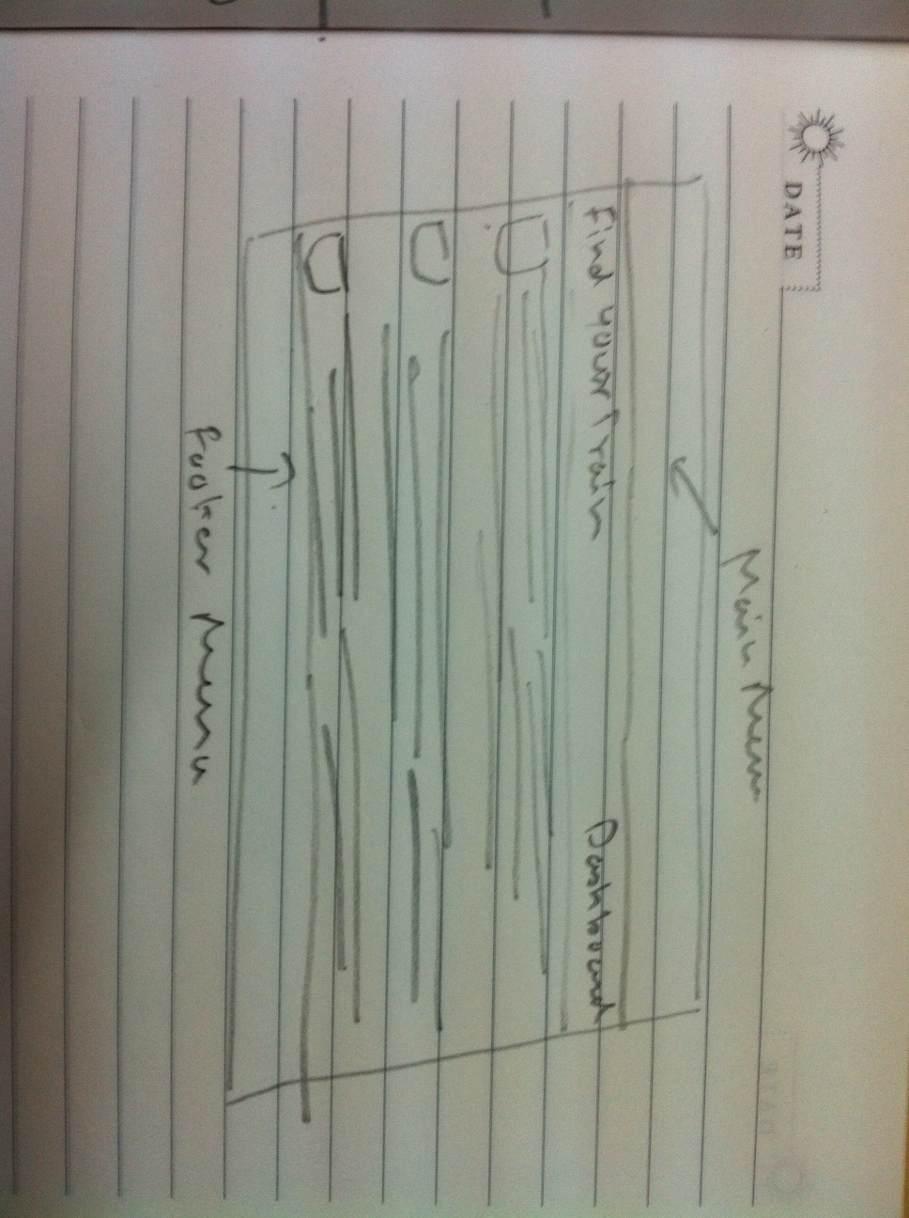

Please fit below on the page layout : The five points would be- Search, Plan, Measure, Track and Improve-

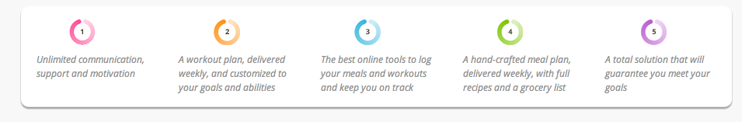

Detail trainer profile display page:

If user clicks on either trainer image or name the respective trainer details page would be display. Similar layout of above, instead of displaying 3 or 4 search result we will be displaying the trainer details. All the details from trainer db except trainer contact details (mobile or email). There will be back hyperlink for user to come back on the search result page. The search should not be done again.

If user clicks on “Dashboard” he/she will return to dashboard page.

2) Trainer registration:

On the home page when user clicks on “Trainers” link, a new page will get displayed (layout below)

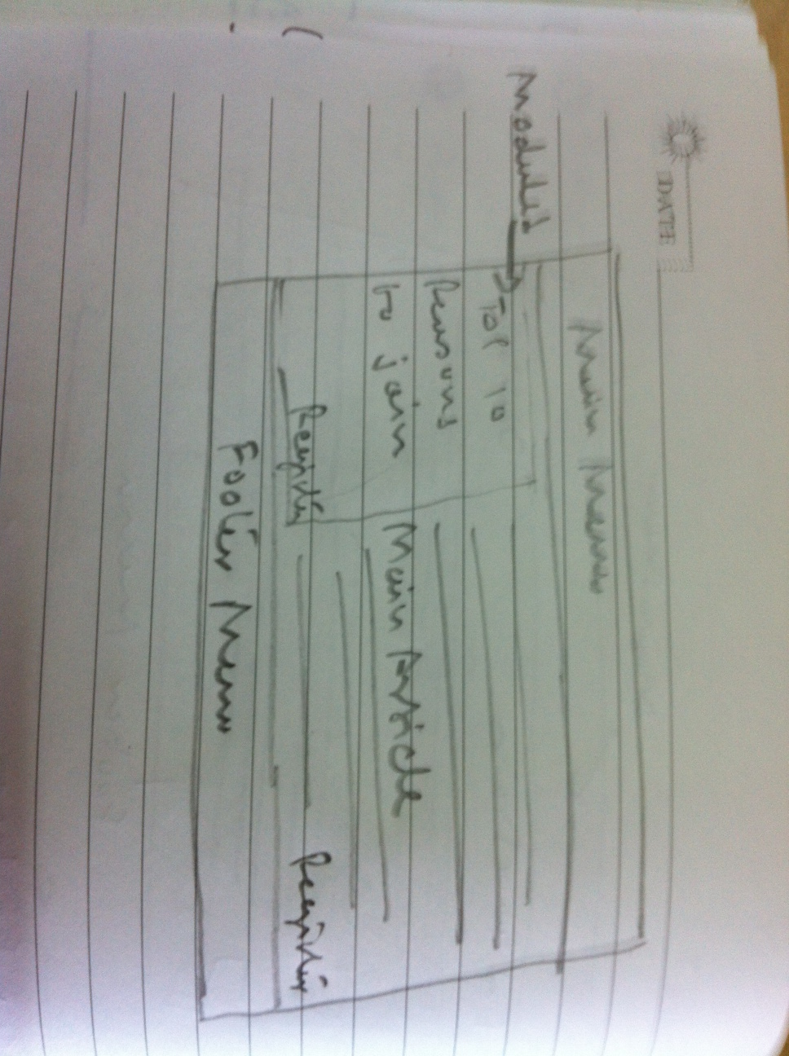

In the main article there will be a small image aligned right corner signifying the benefits and article content.

For registering trainers we can use the same pop-up (for users below) with an additional field- Speciality (dropdown values- Physical Trainer, Nutritionist/Dietician, Physiotherapist, Yoga, Aerobics, Martial Arts). The drop down values and controlled via admin panel.

Following email account activation trainers would require adding other mandatory details. Similar implementation like for user.

fields -

Pic (not mandatory) - should have a provision to either upload or click a webcam.

Secondary skills (same dropdown values as in Speciality) not mandatory

About Me- 4-6 lines of text (not mandatory)

Address (mandatory)- multiple fields to distinguish locality and pincode- total 7 text boxes i.e. 1st- for home name/no., 2nd for road name, 3rd for City (dropdown), 4th for locality (kind of a dropdown as user would get values from DB, 5th for pincode, 6th state and 7th country (dropdown)

Home Phone (including country code- dropdown)

DoB (mandatory)- DD-MM-YYYY calendar to choose from

Gender(mandatory)- dropdown

Years of Experience in primary and secondary skills (dropdown) (mandatory)

Experience summary (Not Mandatory)(details of prior and current experience)- text box for atleast 2 employers current and past.

Consultation fee (monthly)(Mandatory)- text box (in Rs.)

Other data-

Certifications and Education (dropdown) not mandatory

Can take group activities (check box) mandatory

Personal Facebook link (text box) not mandatory

Once above mandatory details updated, trainer would land on their dashboard page. Above is only one time i.e. after 2nd login onwards trainers will land on dashboard directly.

Account activation via email following welcome mail with FAQ’s.

For the edit profile page we can use the above pop-up. Except email, gender and DOB all the other fields can be editable by trainer.

The landing page for trainer would be a dashboard (similar to user one) where trainer would be able to see the list of users under. we can use a multi tab layout to showcase the details of user workout/progress etc and a provision for trainer to input workout schedule, meal suggestion etc.

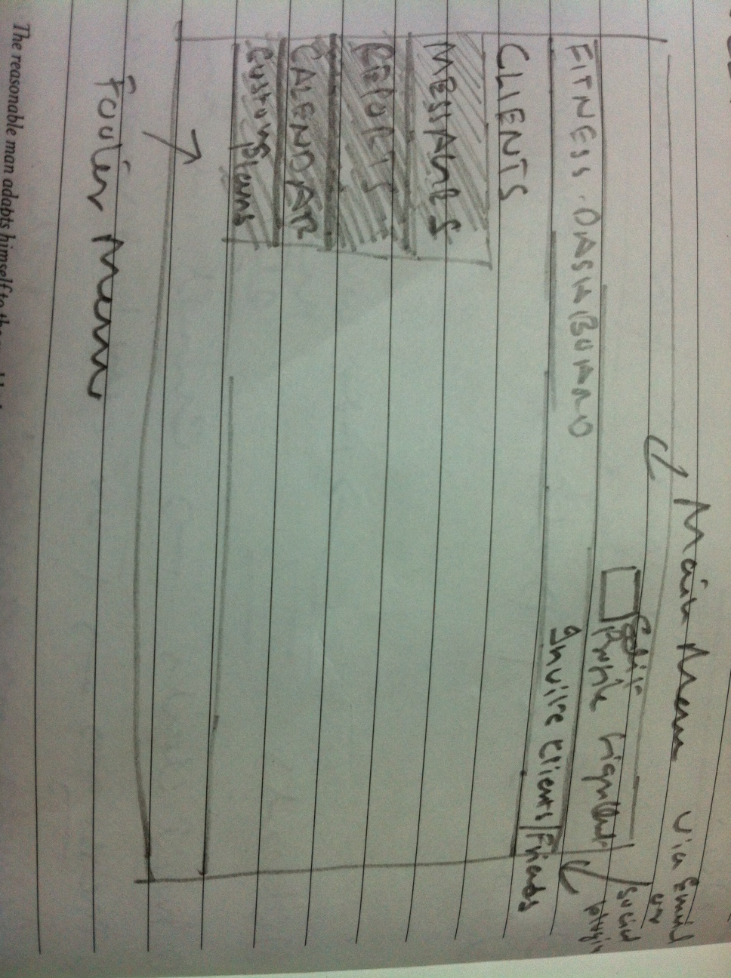

Tabs- 1) Clients: This will list all the client names (hyperlink). When user clicks on a client name then it will open next level details for respective client where trainer will have a provision to add workouts from list of workouts from GymPik or any from his/her custom list (last tab).

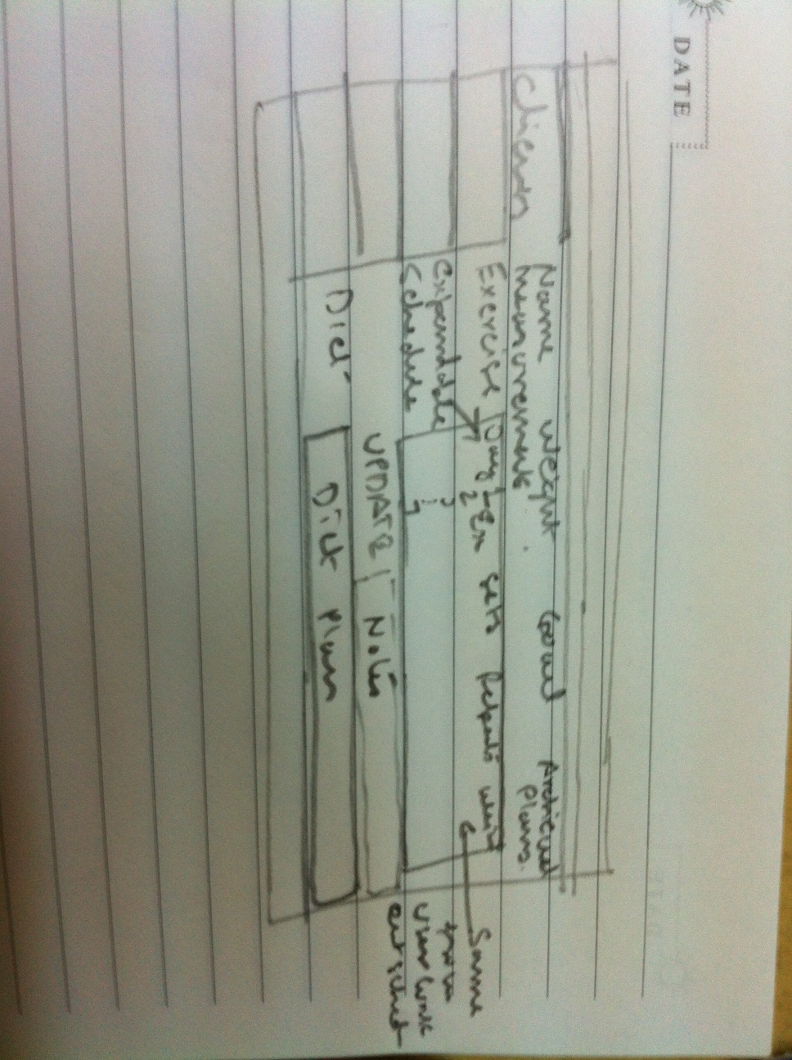

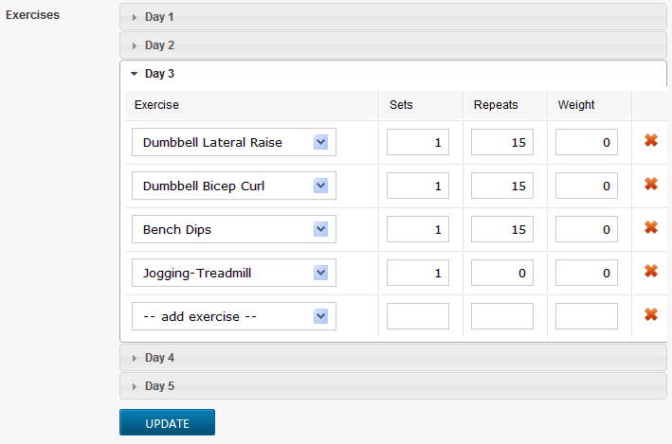

Add exercise will give list from db or user can also type and then respective search will be dropdown. (shown in screenshot below)

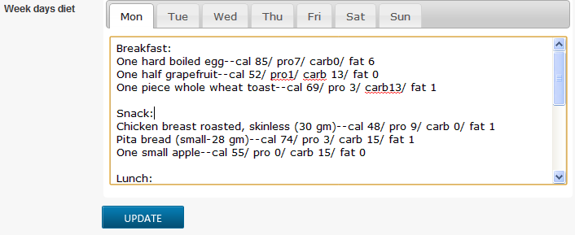

For now trainer/dietician would need to type but for future there should be a provision where if trainer selects pre-populated plans then the values will get assigned to user chart.

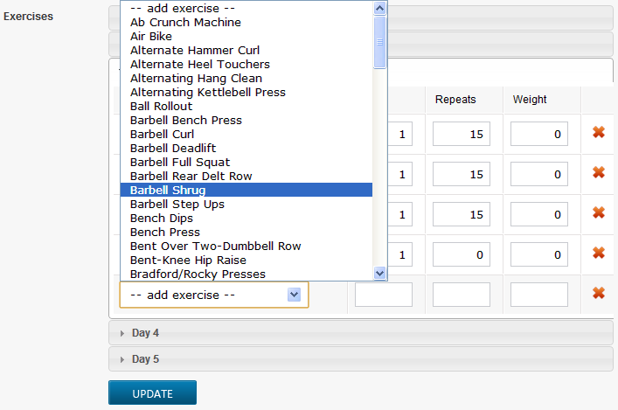

2- Messages- Typical email interface for every single message from any user or admin. One message at time expandable. For reply button a pop-up rectangular box with a plain text box with “To” and “Subject” fields to type in response and submit. The “To” field should list down all the clients and admin email id but there should be a provision for trainer to manually type the email id.

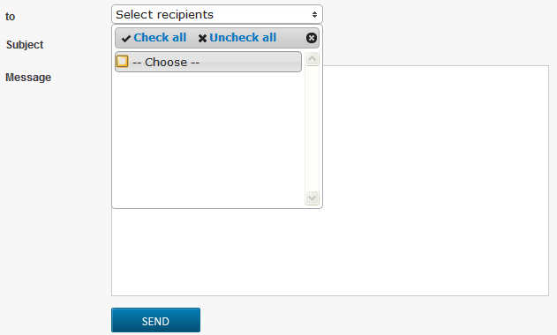

3- Reports: Showing data between 2 date ranges. Data- No. of clients, Active clients and no. of group trainings (This feature will be worked on later in 2nd iteration)

4- Calendar: Typical calendar for a trainer to choose and see his/her schedule. This is just an add-on diary like feature for trainer to keep update and track. For now no other links. If trainer clicks on a day and update an entry eg. 7:00 - 9:00 a.m. training with ABC then this will be saved and shown to trainer if he comes back later to refer. Similar to how we add reminders/meeting to calendar.

5- Custom Plans: In this tab Trainer/Dietician etc will have a provision to create custom plan. This could be a 3day, 5 day or month long plan with listed workouts or diets or even adding something new if it doesn’t exist. For example, physical trainer can add a workout which might not be listed in GymPik DB. For addition this will follow an admin authorization. After authorized the plans/workouts added will only be seen to respective trainer.

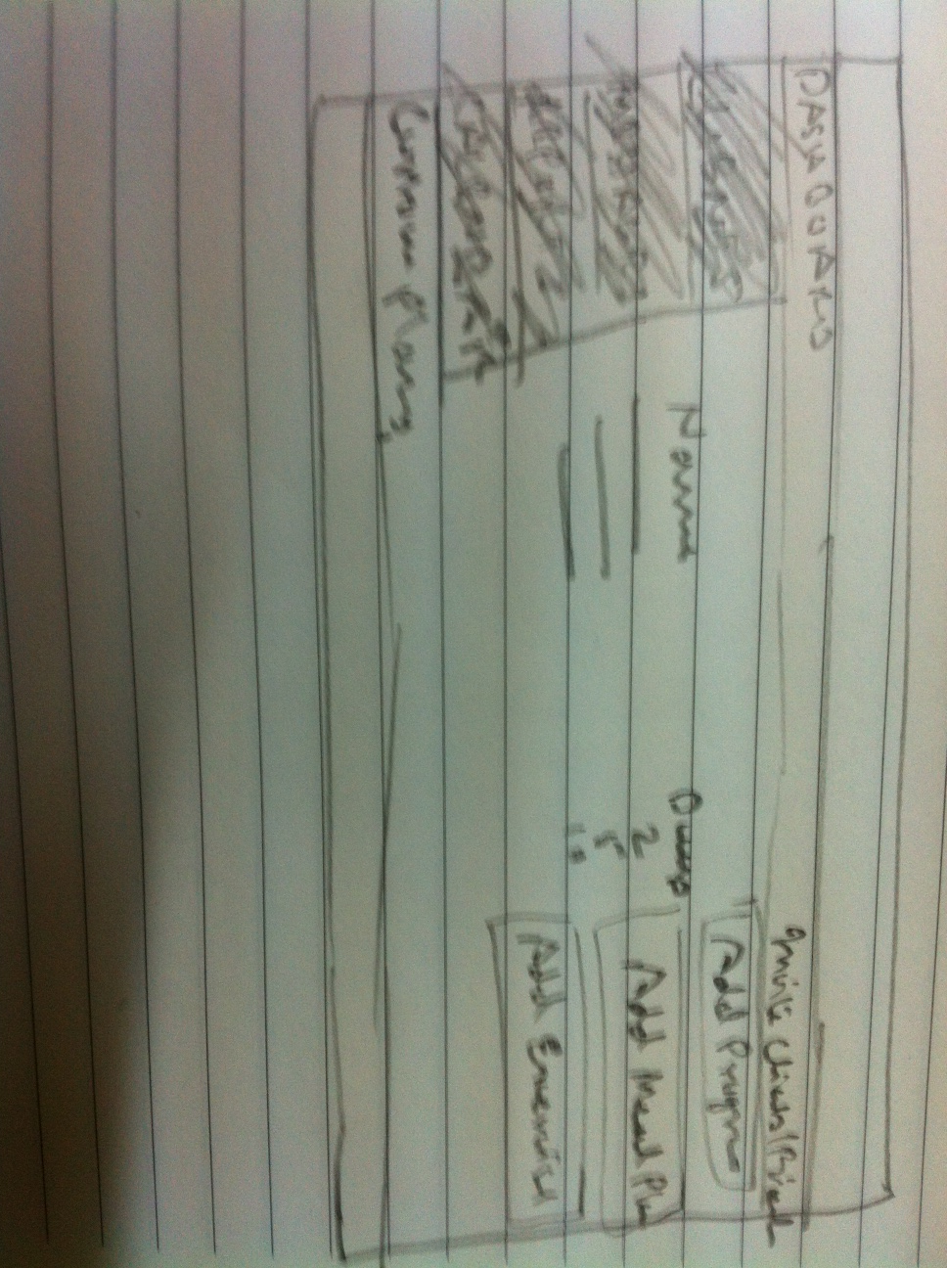

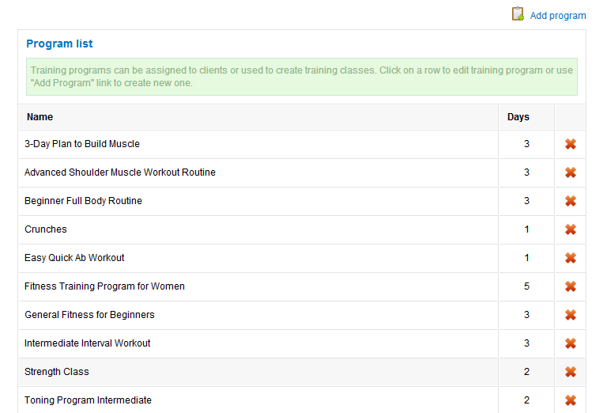

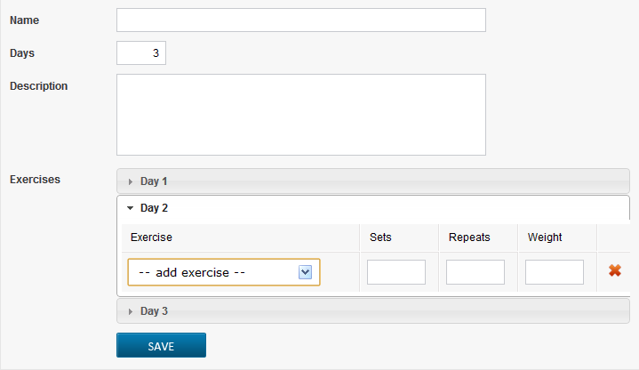

The header and footer menus (one in homepage) should be same for trainer.

Instead of sign-in and registration, sign-out and edit profile

1) Home Page- reference link- <http://web2ease.com/projects/gympik/> (only for layout reference- home page, why gympik and trainers)

a) logo should have a home page hyperlink

b) Menu items- Find your Trainer, Why GymPik, Blog, Trainers, sign-in and register

c) Text slider images: 1)workout with a trainer, 2) exotic food and drinks, 3) Tracking image 4) Before-After image

d) All the text sliders will have 2-4 lines of text

e) First round circle pics- 1) for trainers registration, 2) for users to search trainer 3) for diet suggestions and tracking. For all the three there will be hyperlink and 2-3 lines description

f) Let’s keep one image signifying an end to end healthcare and couple of lines text to explain. This would be the main article of the page. There will be a read more button after couple of lines as shown in prototype

g)For social connect we should have facebook, twitter and pinInterest. Let’s follow respective logo and color what they have.

h) Footer menu- About Us, How it Works, FAQ, Contact Us, Blog, careers

i) 3-4 lines of disclaimer and 2nd footer menu- Terms of Service, Privacy Policy and right aligned disclaimer

Menu Note: The homepage menu should appear if user scrolls down and menu gets disappear. Plz refer the fitorbit.com.

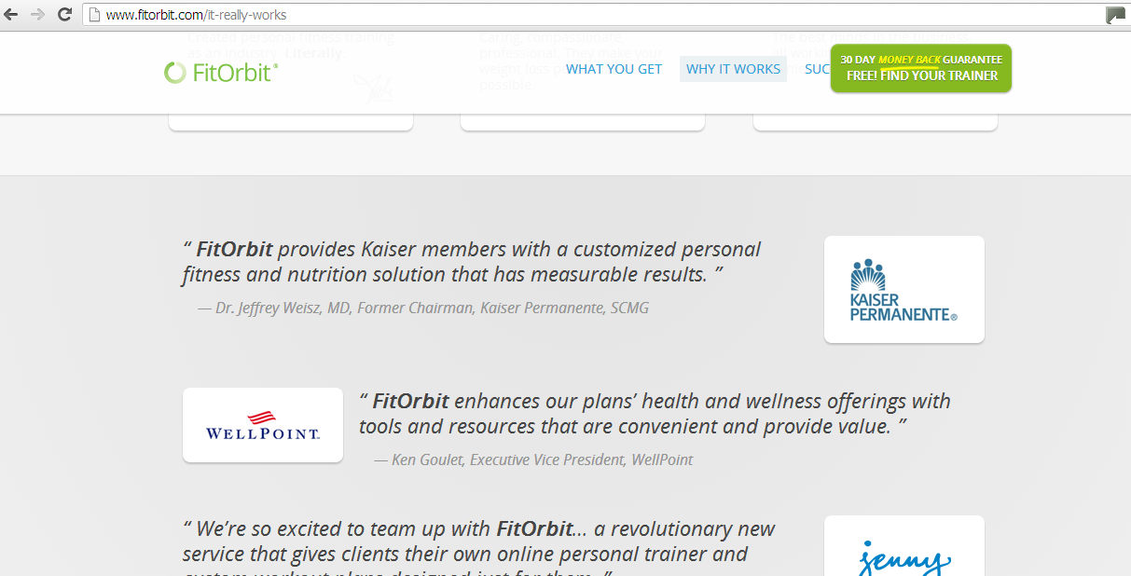

2) Find your Trainer- This should be a pop-up focussed implementation i.e. when user clicks on the “Find Your Trainer” there should be a new rectangular box comes up on top of the current shaded page. In order to cancel the search user can press escape or close. I have seen this implementation mainly for notifications. Eg.

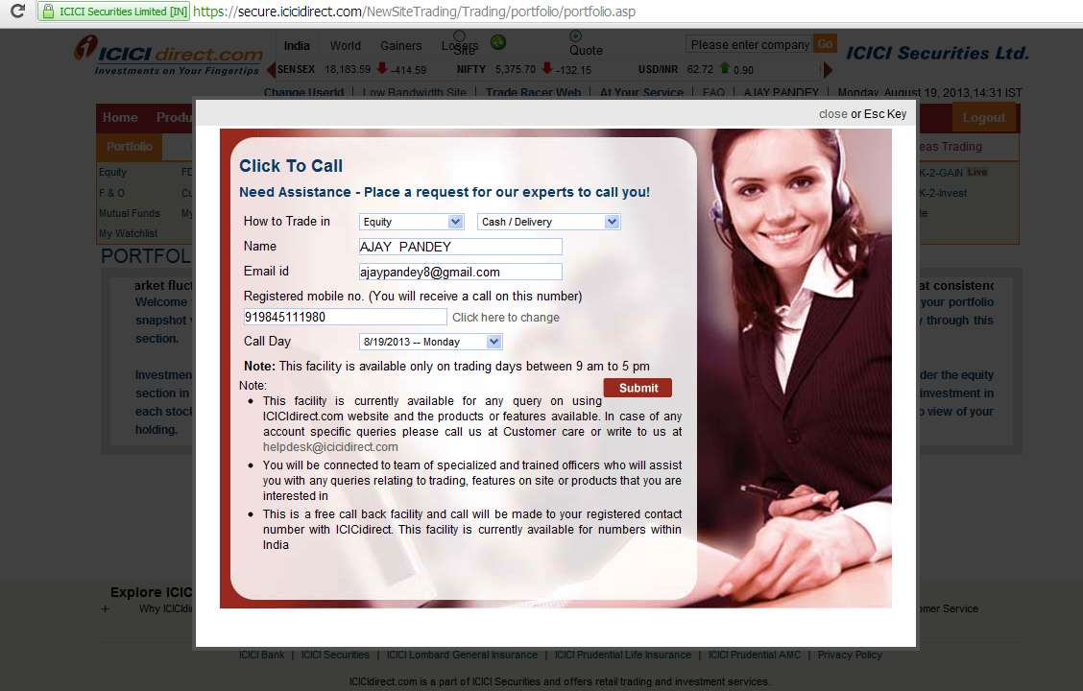

The pop-up would ask series of questions from user for a trainer search. The flow with the fields below:

a) Address: City, Locality, Pincode, Trainer type (dropdown to select which trainer i.e. physical trainer, yoga teacher etc)

b) Trainer preference: Male / Female, How often you need a trainer- (this will be a drop down values- everyday, 3 days a week, 4 times a month), Do you need a dietician consult- Yes or no.

The results would be displayed only in user has logged-in. In case if user lands from homepage then should get prompted for either sign-in or register. ( refer to fitorbit find trainer search)

3) Why GymPik- One rectangular image (circling all the features and benefits around a user) on left. The image should not be more than 2/3 rd of the page width. On the right there will be a main article describing the benefits and features. For now please keep placeholders for page contents (articles)

4) Blog: For now let’s have only one blog. Each article should be in definite size, for example 18-25 lines. In case if there is more content then there should be a readmore link. For now let’s centralize the blog entry from admin screen i.e. any new blog entry made from admin will get updated on this page.

5) Contact- On the left provide a simple contact form fields- First name, Last name, email id, phone no. , Address, City, Zip Code, Comments/Questions and Submit.

On the right hand side- on top provide a embedded google map and below our address including phone and email contacts.

6) Sign-in- Same implementation like search (focussed pop-up rectangular box) with or option given to users:

1) On the left hand side User can sign-in via providing email id and password. There will also be a hyperlink for forgot password.

2) On the right hand side user can sign-in via facebook.

7) Register- Similar implementation like “sign-in”. In the focussed pop-up window User would require to enter only below details:

First Name, Last Name, Mobile, Email id, password, confirm password

*Once the account gets activated via email user would need to enter other mandatory details on first login.

8) Footer menu- About Us: Create a multi-tab page with tabs on left side. The submenus would be: About Us, Team, Advisors, News and Contact Us.

About Us- Few lines of text (main article) with one image in right top corner.

Team- 3-4 circle (black and white) images and brief bio around with a readmore option

Advisors- 5 (same for Team)

News- Let’s not but any banner or image. Mainly few lines of text with a readmore option for a detail article page. For each entry may be 4-6 lines and logo+hyperlink of the source.

Contact Us- same as mentioned above.

9) FAQ- Accordian style 12-15 q’s and answers.

10) Careers: Few lines of text (main article) to outline the work and enthusiasm and then email contact for resume sharing.

11) For - Terms of Service, Privacy Policy: Simple article based plain pages to list the contents.